5 K Walk wwWALK
Pickering Islamic Centre
in Partnership with
St. Pauls On-The-Hill Food Bank

“Walk with us for a Good Cause for the Hunger and the Homeless”
Date: Sunday April. 28, 2019
Time: 11:00 am (rain or shine)
Meeting Place: Masjid Usman - 2065 Brock Rd N, Pickering, On L1V 2P8
Tel: 905-426-7887 www.masjid.ca
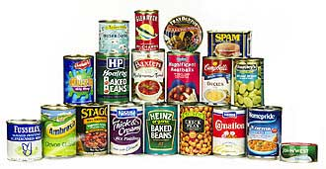

Refreshments provided.

*Participants are requested to bring non-perishable food items to be donated to the food bank. OR GROCERY GIFT CARDS

